Name: C.PAVANI

College: Sri Padmavathi Mahila University

Assignment: 2

Rollno:2022MCA16017

BUTTON COMPONENT:

BUTTON JS:

import React from 'react'

function Button(props) { const {children, style, onClick} = props return (

<button style={style ? style : {background: 'blue', color: 'afff'}} onClick={onClick}>{children}</button>

)

}

export default Button

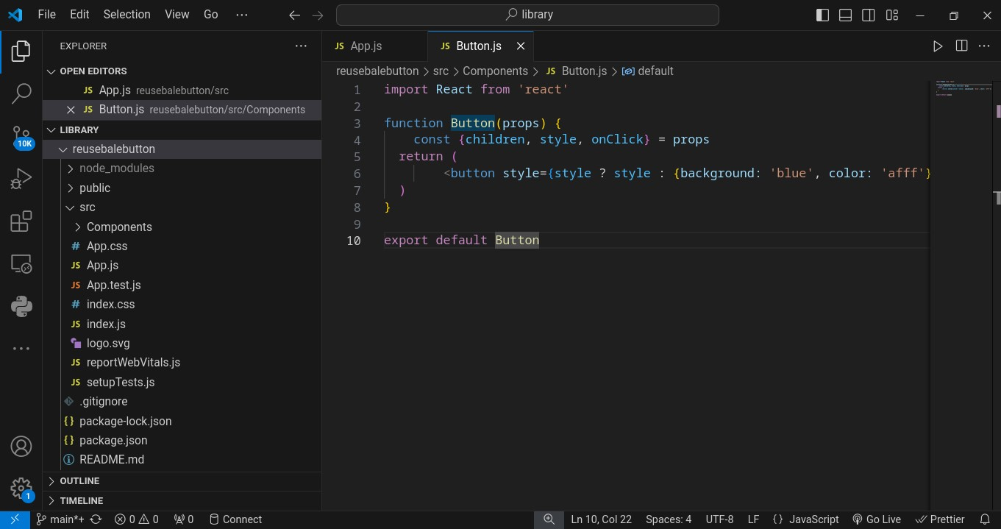

**Card.JSX** import logo from './logo.svg'; import './App.css'; import Button from './Components/Button';

function App() { return (

<div className="App">

<h1> Hello guys</h1>

<Button style= {{background : 'green',color: 'yellow'}} onClick={()=>{alert('button clicked')}}>hello components</Button>

<Button onClick={()=>{alert('welcome')}}>hello components</Button>

</div>

);

}

export default App;

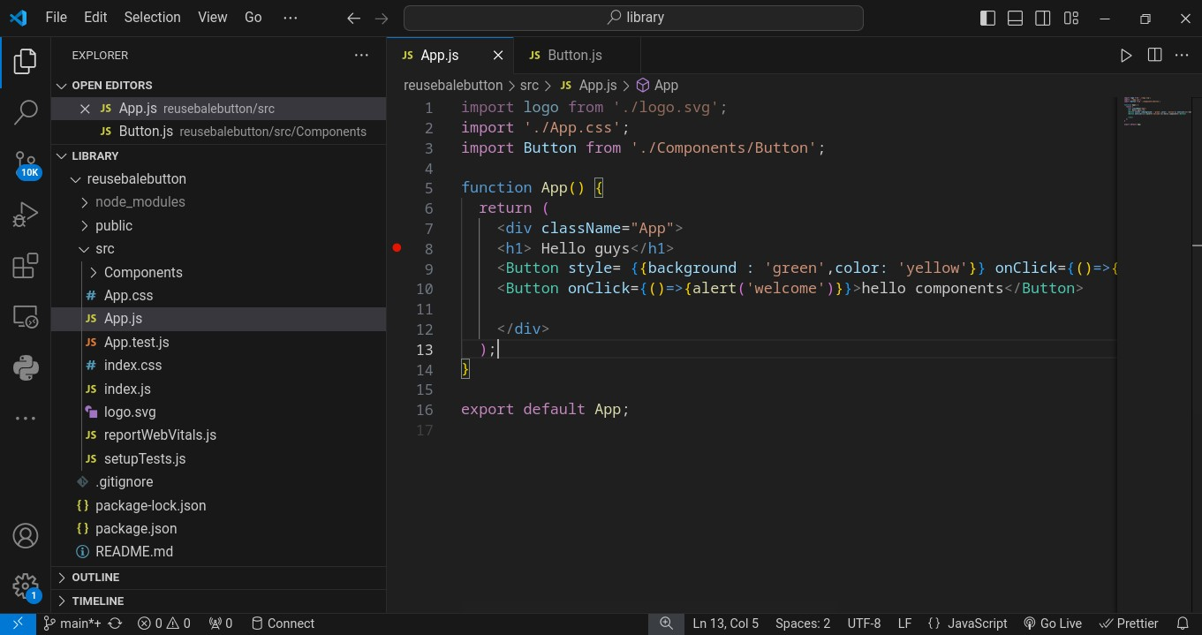

OUTPUT:

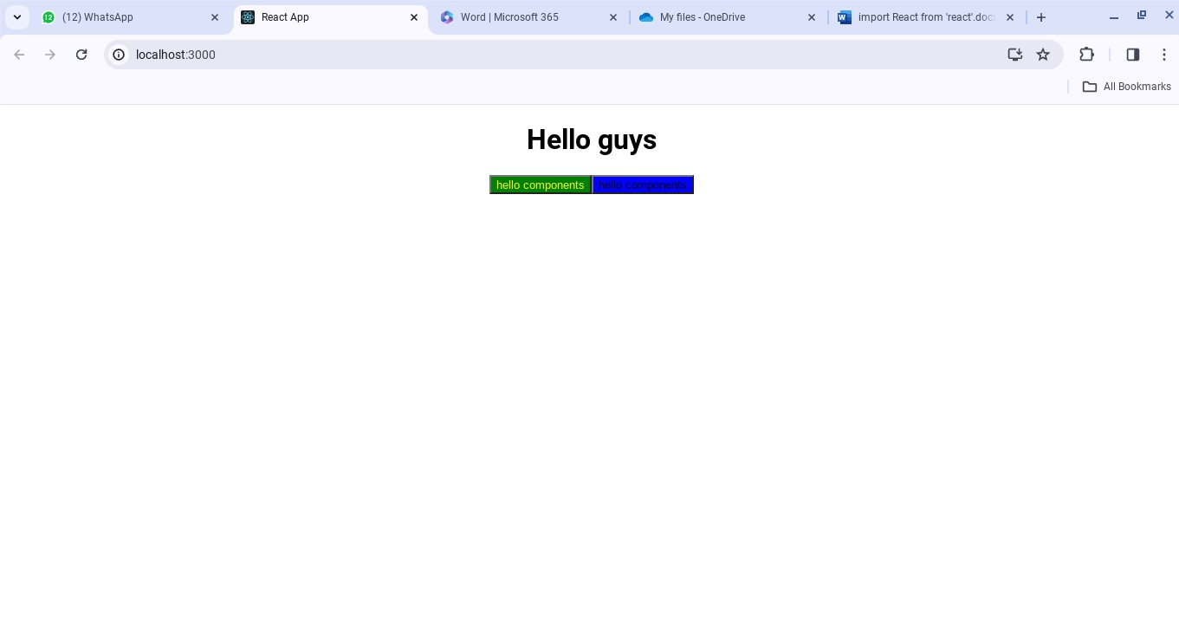

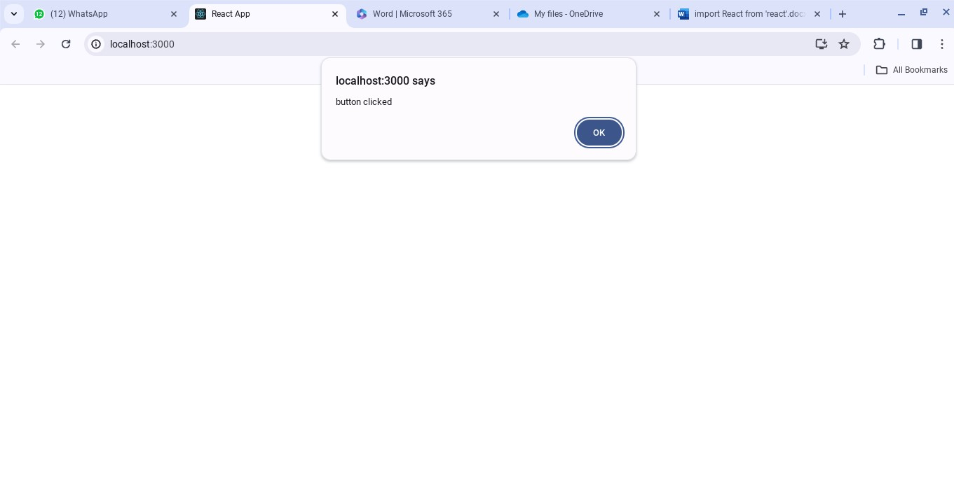

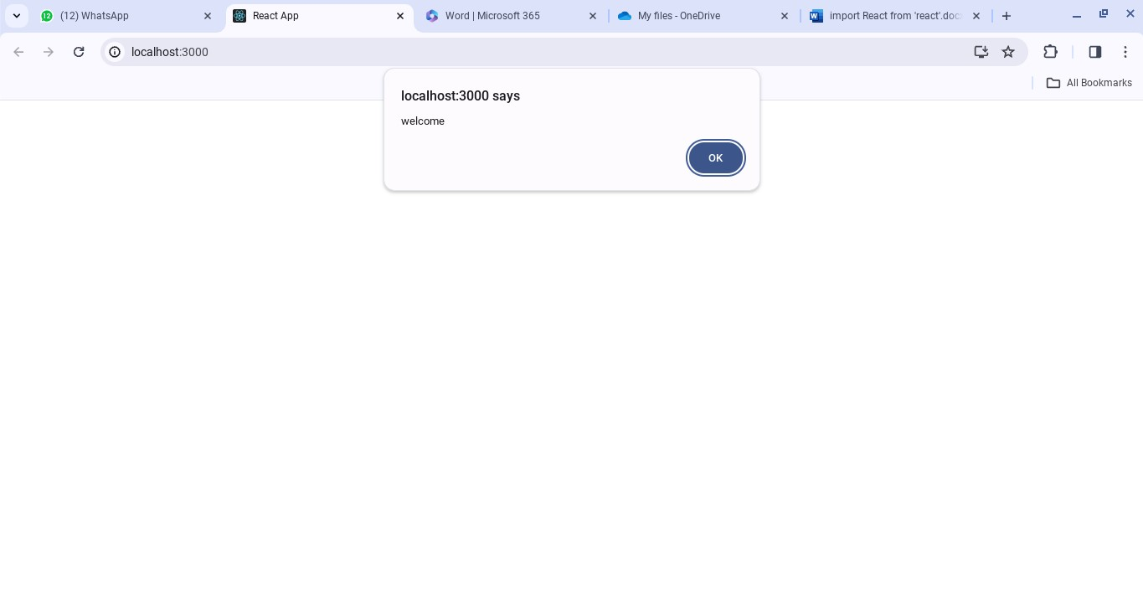

CARD COMPONENT:

CARD.CSS:

# .card-container { width: 15rem;

**border-radius: 1rem; box-shadow: 0px 10px 8px #999; display: flex; flex-direction: column; margin: 0.5rem; background-color: white; height: fit-content;**

**}**

**.card-img { width: 100%; border-radius: 1rem 1rem 0 0;**

**}**

# .card-title {

**margin: 0.5rem 5%;**

**}**

# .card-description { margin: 0.5rem 5%;

**}**

**.card-btn { text-align: center; width: 90%; border-radius: 5px; padding: 0.5rem 1rem; background-color: #2563eb; color: white; text-decoration: none; margin: 0.5rem 0.5rem;**

**}**

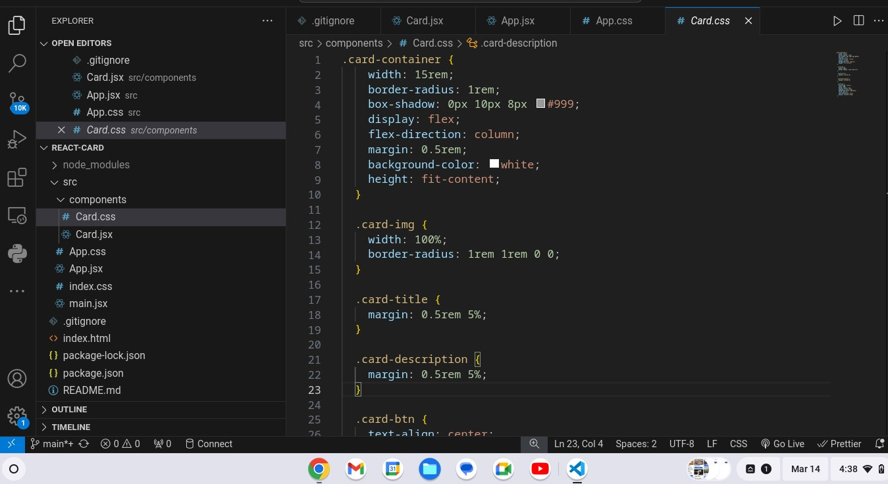

CARD.JSX:

import "./Card.css";

export const Card = ({ imgSrc, imgAlt,

title,

description, buttonText,

link, }) => { return (

<div className="card-container">

{imgSrc && imgAlt && (

<img src={imgSrc} alt={imgAlt} className="card-img" />

)}

{title && <h1 className="card-title">{title}</h1>}

{description && <p className="carddescription">{description}</p>}

{buttonText && link && (

<a href={link} className="card-btn">

{buttonText}

</a>

)}

</div>

);

};

APP.CSS:

**import './App.css'**

**import { Card } from "./components/Card";**

**function App() {**

**return (**

# <div className="App">

**<div className="col"> <Card imgSrc="https://picsum.photos/id/201/300/200" imgAlt="Card Image 1" title="Card Title"**

|  |  |
| --- | --- |
| **description="This is the card description section. You can add more details** | |
| **about the product here"** |  |

## />

**<Card imgAlt="Card Image 2" title="Card Title"**

|  |  |
| --- | --- |
| **description="This is the card description section. You can add more details** | |
| **about the product here"** |  |

**buttonText="Learn More" link="card2"**

## />

**<Card imgSrc="https://picsum.photos/id/193/300/200" imgAlt="Card Image 3"**

|  |  |
| --- | --- |
| **description="This is the card description section. You can add more details** | |
| **about the product here"** |  |

**buttonText="Learn More" link="card2"**

**/>**

## </div>

**<div className="col"> <Card imgSrc="https://picsum.photos/id/211/300/200" imgAlt="Card Image 1" title="Card Title" buttonText="Learn More" link="card1"**

### />

**<Card imgSrc="https://picsum.photos/id/250/300/200" imgAlt="Card Image 3" title="Card Title"**

|  |  |
| --- | --- |
| **description="This is the card description section. You can add more details** | |
| **about the product here"** |  |

**buttonText="Learn More" link="card2"**

### />

**<Card imgAlt="Card Image 3"**

|  |  |
| --- | --- |
| **description="This is the card description section. You can add more details** | |
| **about the product here"** |  |

**link="card2"**

**/>**

## </div>

**<div className="col"> <Card imgSrc="https://picsum.photos/id/106/300/200" imgAlt="Card Image 1" buttonText="Learn More"**

**link="card1"**

### />

**<Card imgSrc="https://picsum.photos/id/193/300/200" imgAlt="Card Image 3"**

|  |  |
| --- | --- |
| **description="This is the card description section. You can add more details** | |
| **about the product here"** |  |

**buttonText="Learn More" link="card2"**

### />

**<Card imgAlt="Card Image 3"**

|  |  |
| --- | --- |
| **description="This is the card description section. You can add more details** | |
| **about the product here"** |  |

**buttonText="Learn More" link="card2"**

### />

**<Card imgAlt="Card Image 3"**

|  |  |
| --- | --- |
| **description="This is the card description section. You can add more details** | |
| **about the product here"** |  |

**link="card2"**

**/>**

## </div> </div>

**);**

**}**

**export default App;**

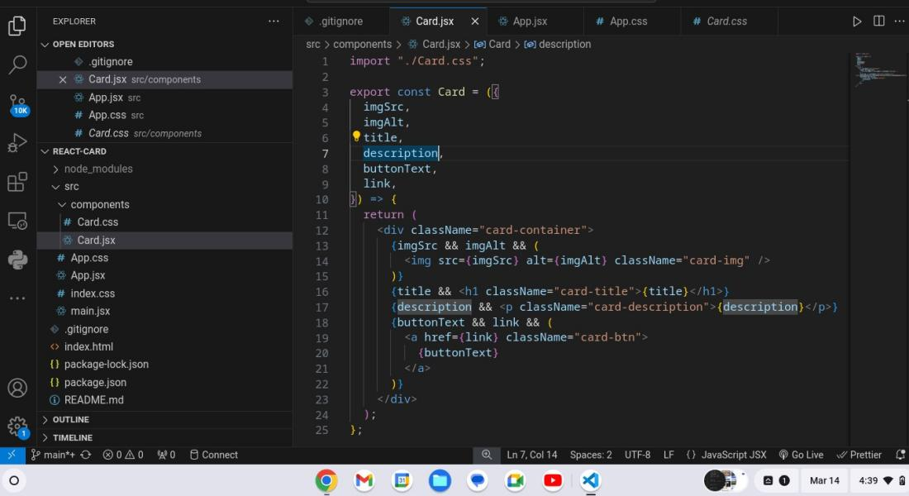

APP.CSS: .App { height: 100vh; display: flex; align-items: center; justify-content: center; background-color: #faf9f6;

}

.col { height: 100%; display: flex; flex-direction: column; align-items: flex-start;

}

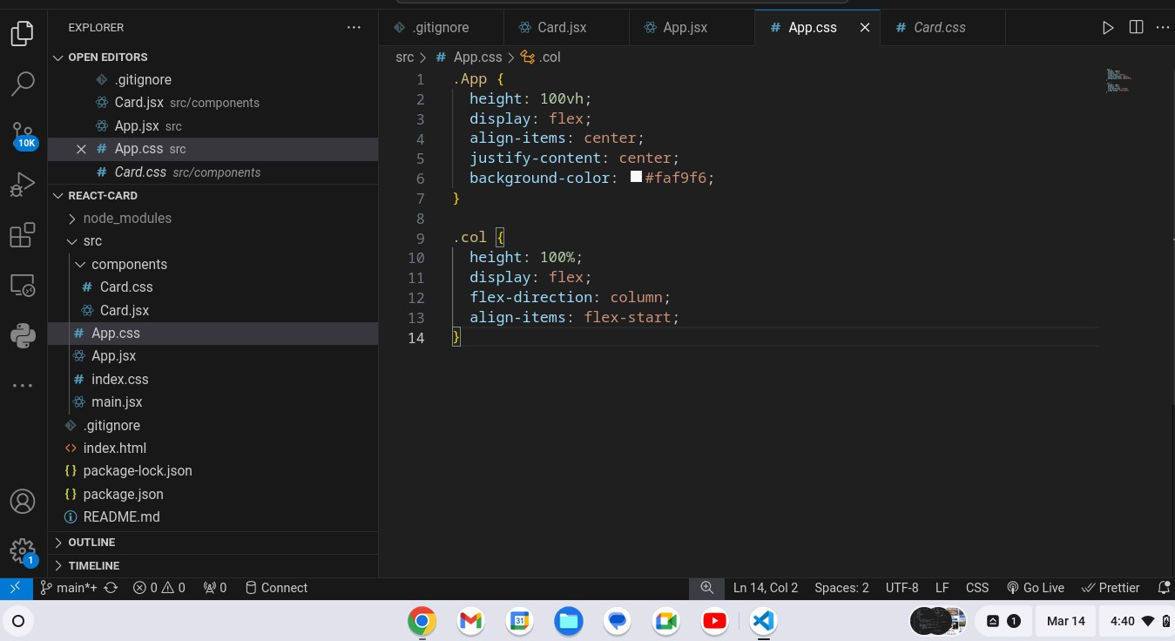

OUTPUT:

